Request for Proposal – R.O.C.K. Strategic Planning

Background
Real Options for City Kids (R.O.C.K.) is an award-winning nonprofit providing positive opportunities for children and youth in San Francisco’s Visitacion Valley. R.O.C.K.’s programs are designed to serve over 500 children ages 6-17 utilizing a proven youth development framework. Programs span the entire year and take place during the school day, after school, weekends and over the summer. R.O.C.K. provides sports/fitness, academic support, learning enrichment, community service, outdoor adventures, leadership training and job opportunities to a community lacking in resources.

R.O.C.K. is proud of its more than 22 years of service and commitment to the community in Visitacion Valley. Faced with new challenges such as the changing nature of the community R.O.C.K. serves, the increasing cost of living and operations in the Bay Area, the proliferation of nonprofits, and the increasing outcomes-orientation of funders, R.O.C.K.’s board and executive staff have committed to a strategic planning process with the ambitious goal of “taking R.O.C.K. to the next level.” R.O.C.K. is seeking to celebrate and build on its 22 years of impact and many significant assets while humbly engaging on the highest-level questions related to its identity and objectives as an organization.

This document provides the scope of work needed for this effort. The final page contains an application template for strategy consultants seeking to support us in shaping our future trajectory.

Request for Proposal
We are requesting proposals to gauge the ability of various strategy consultants to deliver on the scope of work detailed below. All proposals will be due by 5:30 p.m. Pacific Time on Friday, November 11, 2016. Proposals should be sent electronically in a single document to the following: Curt Yagi, Executive Director (curt@rocksf.org). Questions prior to the proposal are welcome and may be submitted via email to Curt; we will reply directly or notify you if we decide to post responses to your question online. Please refer to the table below for all significant RFP dates.

RFP Timeline
RFP Issued | Tuesday, October 11, 2016
Question submission ends | October 28, 2016, 5:30pm Pacific Time
Question responses communicated | October 31, 2016
Proposals due | November 11, 2016, 5:30pm Pacific Time
In-person interviews with finalists completed | November 25, 2016
Final firm selected | December 13, 2016

Each proposal shall include the following:
- A completed proposal – please see the below application form
- Any single sample of work you would like to provide to illustrate previous delivery on the requested outputs
- At least two references for similarly scoped work. For example, work conducted for youth development services that has included both strategy and implementation.
Please note that R.O.C.K. seeks to have this project completed by June of 2017.

Scope of Work

Summary Schematics
At the highest level, R.O.C.K. has three objectives for its strategic planning process:
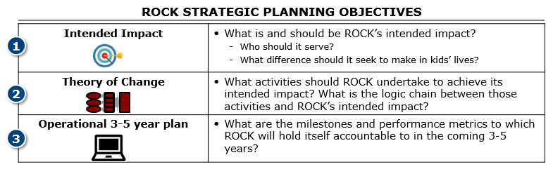

R.O.C.K. expects an appropriate environmental scan, or a “360-degree view” that pulls minimally sufficient data from several sources, will be required to meet these objectives. Data collection should only be done to inform key decisions, but will almost certainly include (un)met community needs, mapping of other actors in the space, perspectives from stakeholders of all types, and research on promising practices. What follows is a suggestive, example visual highlighting key data to be collected:
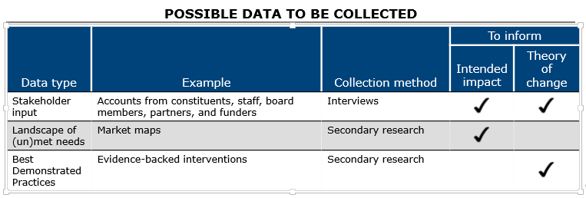

Detailed outputs
Specifically, R.O.C.K. is expecting proposals in the $30-$50k range that at a minimum deliver the following outputs. Please refer to the separate example strategic plan (Youth Inc.) for examples of minimally acceptable quality of each output. Please feel free to suggest and describe additional outputs in your proposal.

The following outputs are required:
- An intended impact statement to drive R.O.C.K.’s work – this will specify (a) who we want to serve, (b) what difference we want to effect in our constituents lives, and ideally (c) on what timeline. This will be coupled with (d) a tight logic chain that links our activities to intermediate and ultimate outcomes (AKA theory of change). Together, these two items will also specify (e) what we will not do. Strong alignment by the board and executive staff on this statement will be critical.
- Clear strategic priorities, with assessments on impact (depth and reach), cost, and a timeline to execute on each priority (AKA action plan)
- Overall costs broken down by initiative and by year
- A fundraising plan that specifies fundraising targets necessary to support our strategic priorities and the actions/investments R.O.C.K. will take to meet those targets (likely informed by a basic funder landscape)
- Detailed organizational implications of pursuing our strategic priorities, including a timeline for hiring additional staff if necessary
- Key performance indicators mapped clearly back to the intended impact statement and using research-backed metrics

Proposals that include the following output will be given preference in selection:
- A communications and change management plan to guide implementation after and, as appropriate, throughout the strategic planning process

Process Timeline
R.O.C.K. is seeking partners to help us complete this work in around 6 months, and ideally before or around June 2017. An example timeline for this work might look as follows:

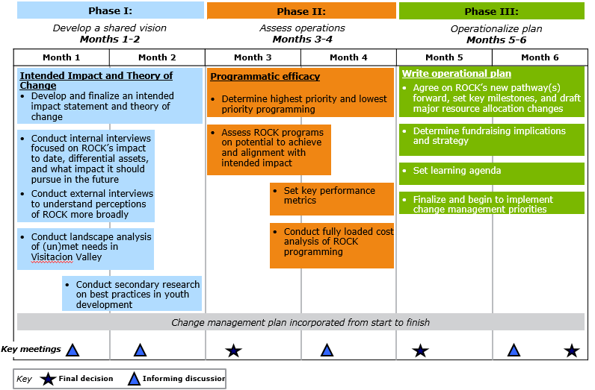

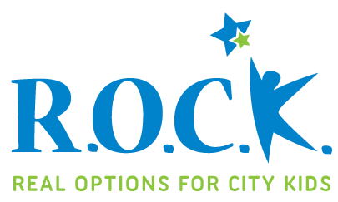
RFP Application for R.O.C.K. Strategic Planning

Please use this page as a template to submit your proposal.

Company Name:
Website:
Contact Name: Contact Title:
Contact Email: Contact Phone:

Questions
Please answer the following questions in your submitted proposal as succinctly as possible:
- Summarize your experience and qualifications for working on this project.
- Give an overview of services you will provide and a timeline to arrive at the above outputs as well as an estimated total cost for the project.
Please refer to the example strategic plan (Youth Inc. document attached separately) and example process timeline in answering this question. We are only seeking partners that can support R.O.C.K.’s arrival at a strategic plan similar to the Youth Inc. plan (in addition to a basic fundraising plan) in about 6 months finishing before or around June 2017. However, we are flexible on the specifics and activities of the process timeline – we look forward to learning from your unique approach and expertise!

- We intend for this strategic planning process to grapple with questions core to R.O.C.K.’s identity, and are searching for partners especially skilled in
  - stakeholder alignment and generating engagement/buy-in among all involved parties (note: the decision-making body for the strategic planning process contains ten board members and two executive staff)
  - framing and addressing only our most important strategic questions
  - gathering and bringing the minimally sufficient data necessary to inform our decisions
Please speak to your abilities to deliver on these three things, using previous client examples as appropriate.

- R.O.C.K. is concerned about “change management” from the very beginning – we want to ensure this work is implemented in full and that our time and money does not become an unused output. What have you done in the past for previous clients, and what will you do for R.O.C.K. to ensure the full process affects future organization decisions and operations?
- What is the size of the team and at what capacity will you staff the team to this project (e.g., 100% vs. 50% of the team’s total FTE time)?

- What additional information would like us to know in considering your proposal?

A basic fundraising plan is not included in the example Youth Inc. strategic plan but is requested as part of this RFP.
A communications and change management plan is not included in the example Youth Inc. strategic plan.

